2. Demonstrate the use of digital write () function by blinking LED
void setup() {
pinMode(LED_BUILTIN, OUTPUT); // Set built-in LED pin as output
}

void loop() {
digitalWrite(LED_BUILTIN, HIGH); // Turn LED ON
delay(2000); // Wait for 2 seconds
digitalWrite(LED_BUILTIN, LOW); // Turn LED OFF
delay(3000); // Wait for 3 seconds
}
Connection:
Connect LED long leg (Anode) → Pin 13
Connect LED short leg (Cathode) → Resistor (220Ω)
Connect other end of resistor → GND
3. Demonstrate the use of analogy write function
int led = 9; // LED connected to PWM pin 9
int brightness = 0; // Initial brightness
int fadeAmount = 5; // Amount to increase/decrease brightness

void setup() {
pinMode(led, OUTPUT); // Set LED pin as output
}

void loop() {
analogWrite(led, brightness); // Set brightness

brightness = brightness + fadeAmount; // Change brightness

// Reverse direction at limits
if (brightness <= 0 || brightness >= 255) {
fadeAmount = -fadeAmount;
}

delay(30); // Small delay for smooth fading
}
Connection
Connect LED long leg (Anode) → Pin 9 (PWM pin)
Connect LED short leg (Cathode) → 220Ω Resistor
Connect other end of resistor → GND
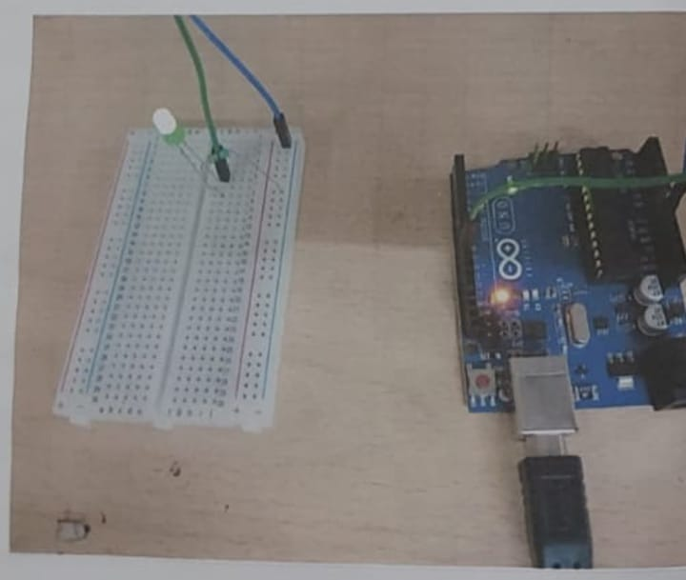

2. Measure temperature of an environment using LM 35 with Arduino
Code;
const int lm35_pin = A1; // LM35 output pin
void setup() {
Serial.begin(9600);
}
void loop() {
int temp_adc_val;
float temp_val;

temp_adc_val = analogRead(lm35_pin); // Read temperature
temp_val = (temp_adc_val * 4.88); // Convert ADC value to millivolts
temp_val = (temp_val / 10); // LM35 gives 10mV per °C

Serial.print("Temperature = ");
Serial.print(temp_val);
Serial.print(" Degree Celsius\n");

delay(1000);
}

Connection
lM35 Temperature sensor to Arduino
Out pinA1
GNDGND
VCC5V

3. Implement push button to control buzzer with Arduino
Code:
int buzzerPin = 8;
int buttonPin = 7;

void setup() {
pinMode(buzzerPin, OUTPUT);
pinMode(buttonPin, INPUT_PULLUP);
}

void loop() {
int buttonState = digitalRead(buttonPin);

if (buttonState == LOW) {
digitalWrite(buzzerPin, HIGH); // Turn buzzer ON
}

if (buttonState == HIGH) {
digitalWrite(buzzerPin, LOW); // Turn buzzer OFF
}
}
Connection Buzzer to Arduino
Buzzer + (long leg) → Pin 8
Buzzer – (short leg) → GND
Connection Push Button to Arduino
One side of button → Pin 7
Other side of button → GND
4. Demonstrate the keypad working with an Arduino
Code:
#include <Keypad.h>

const byte ROWS = 4; // four rows
const byte COLS = 4; // four columns

char keys[ROWS][COLS] = {
{'1','2','3','A'},
{'4','5','6','B'},
{'7','8','9','C'},
{'*','0','#','D'}
};

byte rowPins[ROWS] = {9, 8, 7, 6}; // connect to row pinouts of keypad
byte colPins[COLS] = {5, 4, 3, 2}; // connect to column pinouts of keypad

// Create an object of keypad
Keypad keypad = Keypad(makeKeymap(keys), rowPins, colPins, ROWS, COLS);

void setup() {
Serial.begin(9600);
}

void loop() {
char key = keypad.getKey(); // Read the key

if (key) { // If key pressed
Serial.print("Key pressed: ");
Serial.println(key);
}
}
Connection:
Keypad Arduino
Left to right connection
1-D8
2-D7
3-D6
4-D5
5-D4
6-D3
7-D2
8-D1

5. Detect motion using PIR sensor
Code:
int led = 13; // LED pin
int sensor = 2; // PIR sensor pin
int state = LOW; // Current state
int val = 0; // Sensor reading

void setup() {
pinMode(led, OUTPUT);
pinMode(sensor, INPUT);
Serial.begin(9600);
}

void loop() {
val = digitalRead(sensor); // Read PIR sensor value

if (val == HIGH) { // If motion detected
digitalWrite(led, HIGH);
delay(100);

if (state == LOW) {
Serial.println("Motion detected!");
state = HIGH; // Update state
}
}
else {
digitalWrite(led, LOW);
delay(200);

if (state == HIGH) {
Serial.println("Motion stopped!");
state = LOW; // Update state
}
}
}
PIR to Arduino
VCC → 5V (Arduino)
OUT → Pin 2 (Arduino)
GND → GND (Arduino)
LED Connection to Arduino
(+) legD13
(-) legGND

